RAMAIAH INSTITUTE OF TECHNOLOGY
(AUTONOMOUS INSTITUTE, AFFILIATED TO VTU)
BANGALORE - 54

DEPARTMENT
OF
MASTER OF COMPUTER APPLICATIONS
(MCA)

MOBILE APPLICATIONS DEVELOPMENT
(PROJECT SYNOPSIS)
DIGITAL CARE

Team Members | Guide Name
Dilip Kumar 1MS17MCA13 | Chetan Venkatesh
Asha Sheeba J 1MS17MCA07

Introduction

Purpose
The main purpose of the project is to provide a Children monitoring application for the parents in order to monitor the activities of their children. It records the data of the child location and maintains a history for the same. It provides the location information of the children to the parent

Overall Description

Product Perspective
The Product perspective is of the parent perspective and from which parent can monitor and as well as manage the details/information of the children added in the application.

Module Descriptions
The main function is to track the location of the child based on GPS and it records into the historical data of the parent mobile device. Application provides the login form in which parent needs to enter credentials with unique username/password for each child. This factor is the main constraint.
Functionalities:

Login page
- 'Sign in' using Username and password fields in Login page
- Forgot password option in Login page
- Create 'New user/create account' option in the Login page
Homepage
- Add your children
- Create/Display the child details
- Ability to display the added child
Records Management
- Display name and picture of the child
- Location to trace the child location
- See history
- 'Today Activities' for activities to be done by parent for the child on that respective day
Settings
- Display details of User
- Delete Account

User Interface Design

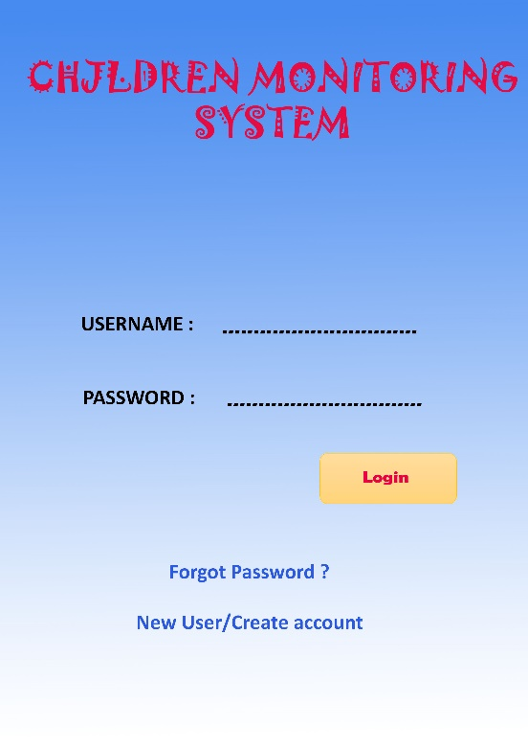

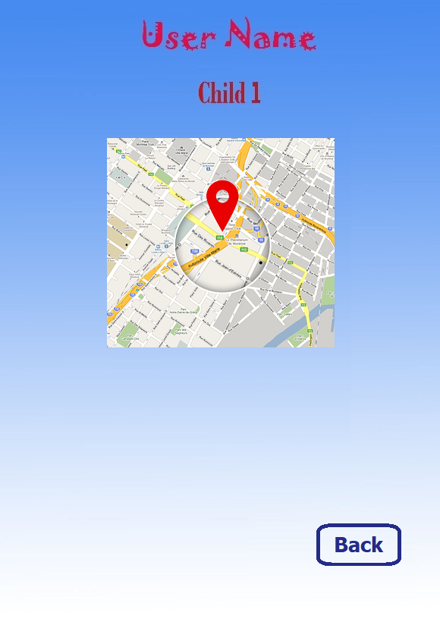

Project Development Timeline

Module Name | Tentative Date and Month
Design | 27/09/2019
Tracker | 09/10/2019
Testing | 25/10/2019
Documentation | 28/10/2019

Workload Distribution

Module Name | Team Member Name
Design | Asha Sheeba J
GPS Location | Dilip Kumar M
GPS Notification | Dilip kumar M
Registration | Asha Sheeba J

